What was done, when, what for and how it was tested (sort of support for the main chapter of my thesis)

ca. November – implementing a simple TAP port emulator in order to have some possibility of making functional testbenches (i.e. If our device fails, we connect it with this model and run a testbench). Pretty useful + it seems to work. Wrote a special testbench basing on figures from IEEE 1149.1 specification.

December – starting to write the actual TAP controller. Right now, it should do something to prove that it works: read DevId or just bypass everything. First tests should give some results visible in SignalTap or ChipScope (unless it is not enabled in ISE's web edition).

January – First tests ran on De2-115 board at work. Project didn't run as predicted, therefore TAP emulator was used to verify the design. Moreover, Windows version of Quartus is hopeless, but I've already mentioned it billion times.

February – Starting tests on Spartan-3E board (stopped for a moment because I ran out of goldpins and it's weekend). Ported project to Spartan-3E evalboard. Maciek, thanks for lending the board if you happen to read it!

February cnt. - DE2-115 board was used to shift out Discovery's Cortex and Boundary Scan IDCODEs. Both reads were successful. SignalTap results are on my e-mail.

Feb/March – DE2-115 board was used to perform DPACC/APACC operations. For some reasons, read/write of DPACC registers work.

March – Spartan 3E board w/Spartan XC3S500E was put under test (using IDCODE, BYPASS and USERCODE).

March – reverse-engineering of AVR XMEGA A3BU evaluation kit with Atxmega256a3bu processor. Its point was to record what is sent by Atxmega when AVR Studio performs its IDCODE operation. JTAG signals were supervised on a 4-channel Tektronix' scope. Digital channels were used in the beginning, but because of problems with csv data export 4 analog pins were used (however, snapshot of digital channels was made for a reference) to capture TMS, TCK, TDI and TDO signals. Analog waveform was pretty wide (356 Mb wide) – since now, only one relevant part of it was found.
Instruction register of Atxmega256 was guessed from its BSDL file. In fact, instruction register was only 4-bits wide and IDCODE code was "0011". Evaluation board's scan chain consisted only of this microcontroller, therefore task seemed to be easy because there was no additional chip to be put into BYPASS mode.
Later, the same IDCODE operation was performed by using a custom JTAG module in DE2-115. Atxmega's response was recorded in SignalTAP (NOTE: since author quit her job, she needs to buy DE0 to use SignalTap and it's about time to do that to make use of a discount for students in kamami.pl). IDCODE recorded in Tektronix waveform was compared to IDCODE obtained by custom application and IDCODE value in Atxmega256xxx's bsdl file. These values were almost similar – the only difference occured in 4 MSB bits responsible for the revision number, what was reasonable. However, vendor and product id were identical.
Pictures are in "Atxmega256" directory.

April – reverse-engineering of SWD protocol based on ST-LINK v2.5.1 and STM32F40xx Discovery board. The target board was connected to the computer and SWD communication was observed on a scope. Fortunately, SWD pins were ported to I/O pins PA13 and PA14, therefore assembling took only a moment.
This time, evaluation version of Origin 9.1.0 was used to process output data (author doesn't support piracy, hence she downloaded 21-days trial version).

More precised description below.

More precised description

1. Implementation of a TAP port emulator

In the first step, Test Access Port emulator was implemented, basing on [Iee]. The main purpose of creating the VHDL version of emulator was to obtain a self-standing and transparent TAP device that could be connected to the project and act as a real TAP controller. As a result, identifying all the errors and latches present in the actual project would be simplified and some kind of a functional testing could be applied.
The implemented solution consists of two main functional blocks put in separate entities:

* TAP - the Test Access Port entity that includes TAP-specific signals used to drive the Instruction/Data register entity. It also includes the IEEE 1149.1-based TAP state machine;
* JTAGIDRegister – the Instruction and Data register entity that includes aforementioned registers and a rudimentary mechanisms used to recognize shifted instruction and update it as well as choose the appropriate data register located between TDI and TDO.

TAP and JTAGIDRegister entities are shown on snippet [można napisać snippet?-NP] 1.1:

entity TAP is
port(
TMS: in std_logic; --mode select: sampled at rising edge of TCK to determine the next state
TCK: in std_logic; --synchronizes intenal state machine operators
TRST: in std_logic;
--output signals
CLOCKIR: out std_logic;
UPDATEIR: out std_logic;
SHIFTIR: out std_logic;
TRESET: out std_logic;
TSELECT: out std_logic; --TSELECT: SELECT is a reserved name!
ENABLE: out std_logic;
SHIFTDR: out std_logic;
UPDATEDR: out std_logic;
CLOCKDR: out std_logic;
--optional signals used to set some values
CAPTUREDR: out std_logic;
CAPTUREIR: out std_logic
);
end TAP;

entity JTAGIDRegister is
port(
--serial input/output
TDI : in std_logic;
TDO : out std_logic;
TCK : in std_logic; --required for events occuring @ falling edge of TCK. Me thinks.
TRST : in std_logic; --asynchronous reset
-- instruction register:
SHIFTIR : in std_logic;
CLOCKIR : in std_logic;
UPDATEIR : in std_logic;
TRESET : in std_logic; --reset from TAP (@ falling edge of TCK in Reset state)
--data register:
SHIFTDR : in std_logic;
CLOCKDR : in std_logic;
UPDATEDR : in std_logic;
--optional signals used to set some values
CAPTUREDR : in std_logic;
CAPTUREIR : in std_logic
);
end JTAGIDRegister;

Snippet 1.1 TAP and JTAGIDRegister entities

For an educational purpose, version with boundary scan cells was implemented as well, even though it wasn't used in further applications.

A special testbench was implemented in ISim in order to test the functionality of the emulator. The main purpose of this testbench was to reproduce TAP's waveforms present in [Iee, p. XXXX], further considered as a reference pictures. Emulator was considered passed if the same given input sequence of the JTAG pins gave the same output signals sequence and the same states transition as in the reference pictures. Comparison of final results versus the reference is shown on Fig. XX.

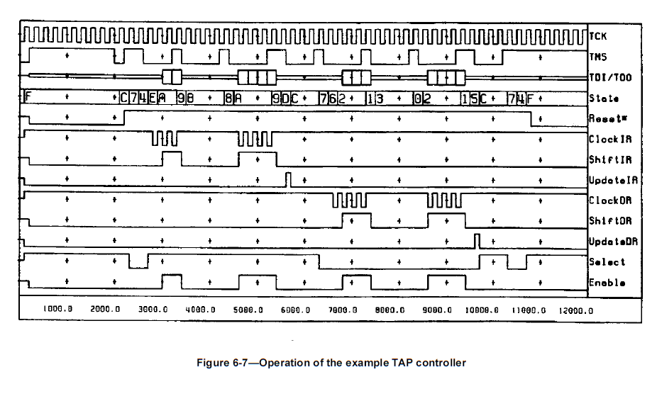
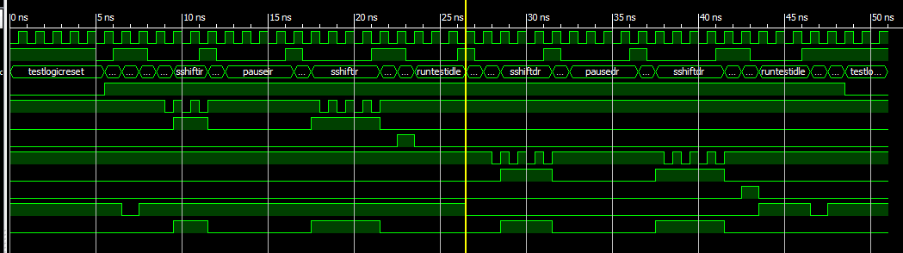

Fig.XX Reference picture vs. Waveform obtained in Isim

Basing on the testbench results, it was stated that TAP controller emulator gives the same functionalities as the original TAP controller.

2. Implementation of a simple communication via JTAG interface

A separate project was created in order to implement a simple communication with STM32F4 Discovery evaluation board via JTAG interface. The main part of the project was a state machine consisting of 3 states with the following transitions as shown on Fig. XX:

RESET
RUN
DATAREG

Trigger
ON

Last bit shifted
(TMS)
Max prescaler
value

Fig. XX JTAG communication state machine

- Reset – default idle state entered after asynchronous reset. After the trigger sequence, system goes into Run mode;
- Run – mode in which TMS and TDI values are changed in order to reach the SHIFTIR state, load the proper instruction and then proceed to the SHIFTDR state. Once shifting the last bit into TMS and reaching the maximum value of a clock prescaler, system goes into DataReg mode and TMS value is changed to 0;
- DataReg – mode in which a specified data register is placed between TDI and TDO ports. User can send a custom sequence of TDI values by using a separate knob or button placed on the evaluation board and observe the behavior of the TDO port value on a LED or by using SignalTap.

In the first test, BYPASS instruction was shifted into instruction register of both Cortex-M4 and STM32F4's boundary scan register. In that case, TDO value was just a TDI value delayed by 1 clock cycle. As a result, user could control TDI value by a knob and watch TDO value on a chosen LED diode, as shown on Fig. XX.

TBD: zrobić zdjęcie układu w takiej sytuacji (logiczne '0' i '1').

Fig. XX TDI and TDO values when bypassing both Cortex-M4 and STM32F4's boundary scan register

In the second test, IDCODE instructions of Cortex-M4 processor and STM32F4 Discovery's debug port were shifted out. Both instructions were shifted separately – if one component's instruction was read, the second component remained successfully in BYPASS mode.
TDO value was supervised in SignalTap. Exact waveforms are shown on Fig. XX and Fig. XX.

TBD: wrzucić waveformy z maila studenckiego – chyba lepiej w poziomie, bo są duże.

Fig.XX IDCODE value of STM32F4's debug port shifted out on TDO

Fig.XX IDCODE value of Cortex-M4 shifted out on TDO

Both obtained id values were identical with IDCODE values for these components, according to [Stm, p.1670 -Cortex M4 and 1667 – JTAG debug port]. Therefore, test was considered successful.

APACC/DPACC instruction codes

Simple operations on access/debug point registers were performed in the following sequence:

- Write a DP/AP register and then read its value;
- Try to read a value from a known address (this requires some operations with switching between DPACC and APACC instructions, ref. Table in [Jwo] on p.3).
For the time being, read/writes for DPACC instruction work perfect (tested for APSELECT=0b10) and there are some troubles with APACC registers because read operations always returns 0x0000:0000 – no matter which address is being read. This needs further investigation from my side. To read/write DP registers, the following code describes a sequence that was sent on TDI and TDO:

constant ToShiftIR: std_logic_vector (0 to 9):= "0000001100";
constant ToShiftDR: std_logic_vector (0 to 4):= "11100";
constant ToRun: std_logic_vector (0 to 2):="110";
constant DRReturnData: std_logic_vector(0 to 4):="11100";
constant FromDRToIR: std_logic_vector(0 to 5):="111100";

constant ILength: integer :=8;
constant RunLength: integer:=105;

constant IRData1: std_logic_vector (Ilength downto 0):= "010111111"; --"011111111"; --Instruction code to be sent to JTAG
constant IRData2: std_logic_vector (Ilength downto 0):= "110111111";

constant AllZeros: std_logic_vector(0 to 35):="000000000000000000000000000000000000"; -- czy da sie to robic nie w tak lopatologiczny sposob?

constant data_TMS: std_logic_vector (0 to RunLength):= ToShiftIR & AllZeros(0 to Ilength) & ToShiftDR & AllZeros(0 to 35) & DRReturnData & AllZeros(0 to 35) & DRReturnData;
constant data_TDI: std_logic_vector (0 to RunLength):= allzeros(0 to 10) & IRData1 & allzeros (0 to 4) & "001000000000000000000000000000011110" & allzeros(0 to 4) & "101000000000000000000000000000011110" & allzeros(0 to 3);

In that case, some port and some AP bank were first modified with write operation and then read. Results are shown on Fig.XX

Fig.XX – przebieg z SignalTapa.

Spartan-3E board

There are some problems with JTAG pinout on the board- TCK signal is usually observed on TDO (which is its adjacent pin). BYPASS command works and IDCODE shows value slightly different than expected (ref. [BSD], lines 653-657). To confirm that, multiple IDCODE commands were given, each with same "slightly different" result. SignalTap waveform is shown below. Later a .csv file with the measurement will be added.

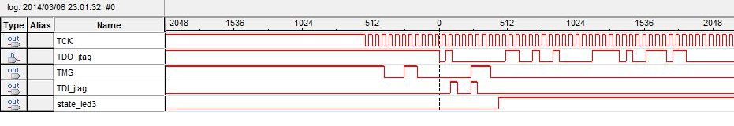
Obtained result is: 0b1100:1001:0000:0111:1010:0111:0110:0000
Expected result [BSD] is: 0b1100:1001:0000:0100:0100:0011:1000:XXXX

It can be seen that manufacturer code matches the value given in [BSD]. At the moment USERCODE is being supervised.

[FIXED] no, it should be like that. We observe ID of an auxiliary chip, xc2c64a, is observed. Its ID equals 0b1100:1001:0000:XXX1:1010:0111:0110:XXXX and it matches. In fact, a scan chain is formed as shown in iMPACT:

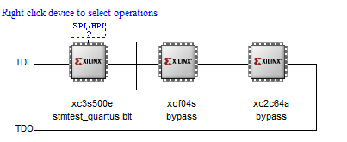

Fig. XX Scan chain of Digilent's SPARTAN 3E board as shown in iMPACT programmer

TBD take idcode of all the components.

Reverse-engineering of SWD protocol

The following obtained waveforms are saved in Doc\Appendix\SWD-STM32F4 directory:

- swd_connect – sequence sent when board is connected to the computer. It is repeated in short periods – probably as a sanity check of the device. What was identified:
1. By now, first sequence (first 8 bits) seems incomprehensible – but 32-bits of data are equal to 0xE004 2000.
2. Second and third sequences are identical. Their role is probably to read DBGMCU_IDCODE register present under address 0xE004:2000 – hence, ST-LINK obtains device ID and revision of the device (respectively 0x413 and Z). Haven't decyphered commands yet.
- (more waveforms, i.e. Regarding different STM processors, coming soon).

References

[Iee] IEEE JTAG1149.1-2001 Standard;
[Jwo] Bob Seabrook, Jworker leaflet, http://www.seabrooks.plus.com/jworker/current-download/;
[Stm] STM32F405xx/07xx Reference Manual, RM0090;
[BSD] BSDL file for XC3S500E in , http://bsdl.info/view.htm?sid=6530f85f94d27f6d88ca59b002289d77 .

